HOW TO USE

**At the Actual System :**

1. First connect the power adapter to the actual system checks for the welcome message on the LCD Display.

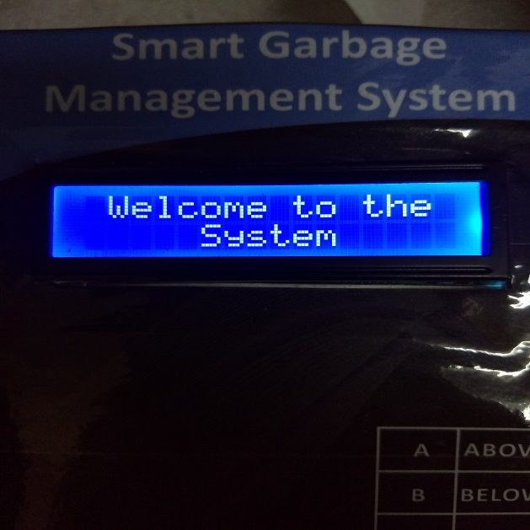

1. Now then the welcome message is on the LCD display then there will be the initial status i.e bins are empty will be displayed on the LCD display

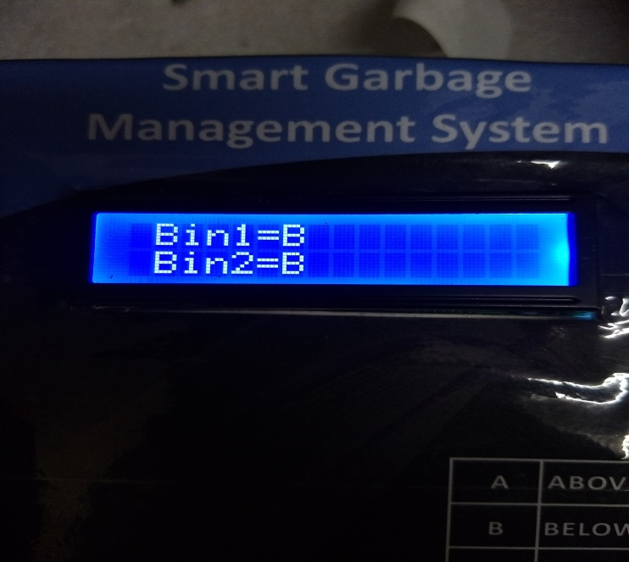

1. And now if the bins are half filled of there will be following message will be displayed.

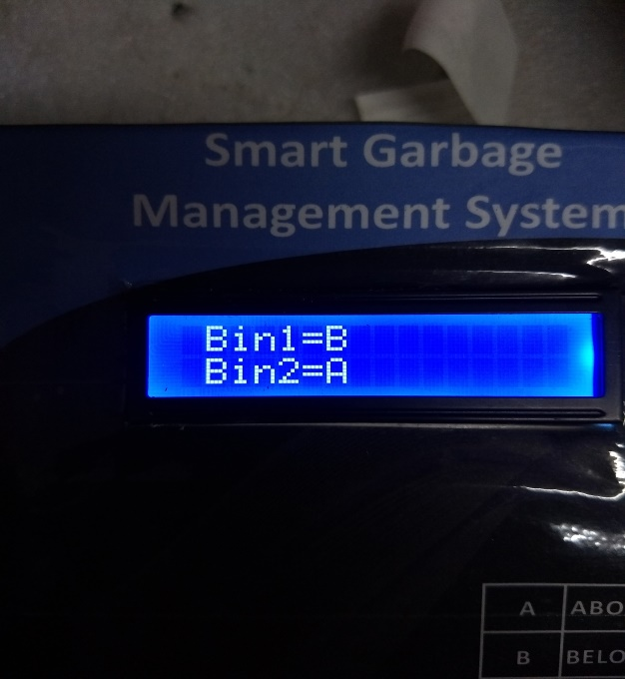 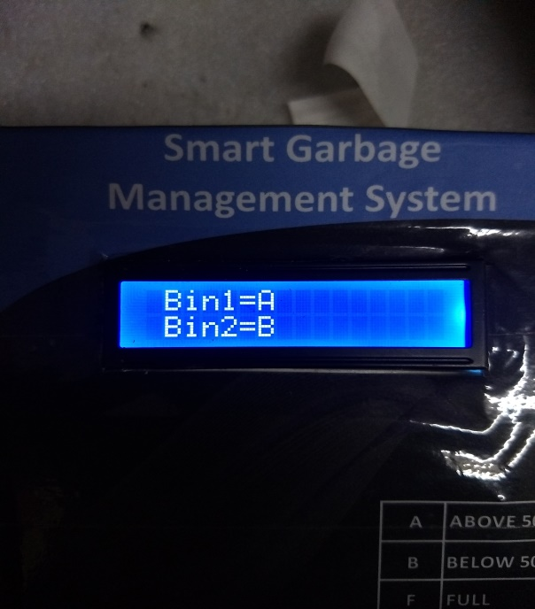

1. And now then if the bins are fully filled then there will be following message will be displayed on the screen.

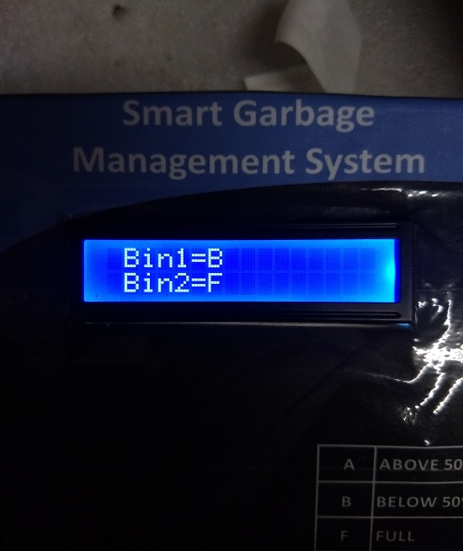 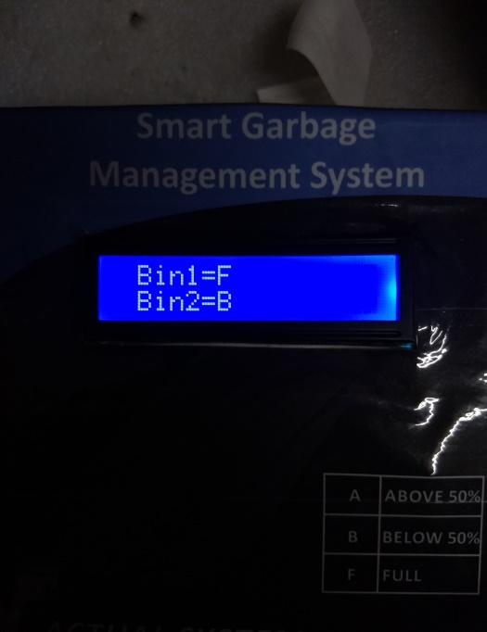

1. Now lastly if there bin is fully filled and if the user is still opens the lids of the bin to add some more waste then the buzzer will be switched on.
2. At the MQTT Cloud the following data is send and is displayed on the cloud window.

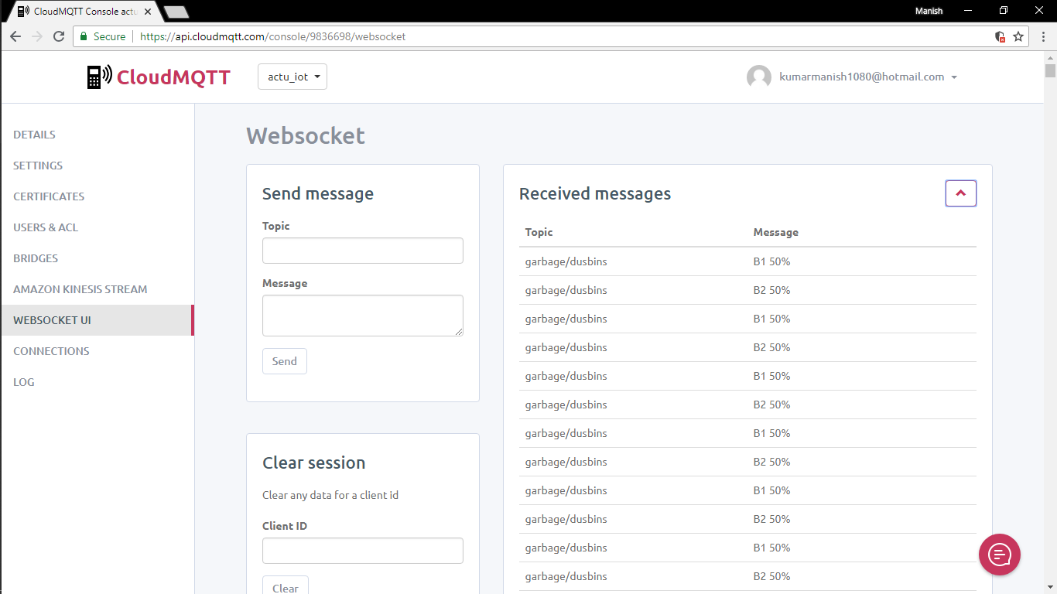

**At the Actual System :**

1. First connect the power adapter to the actual system checks for the welcome message on the LCD Display.

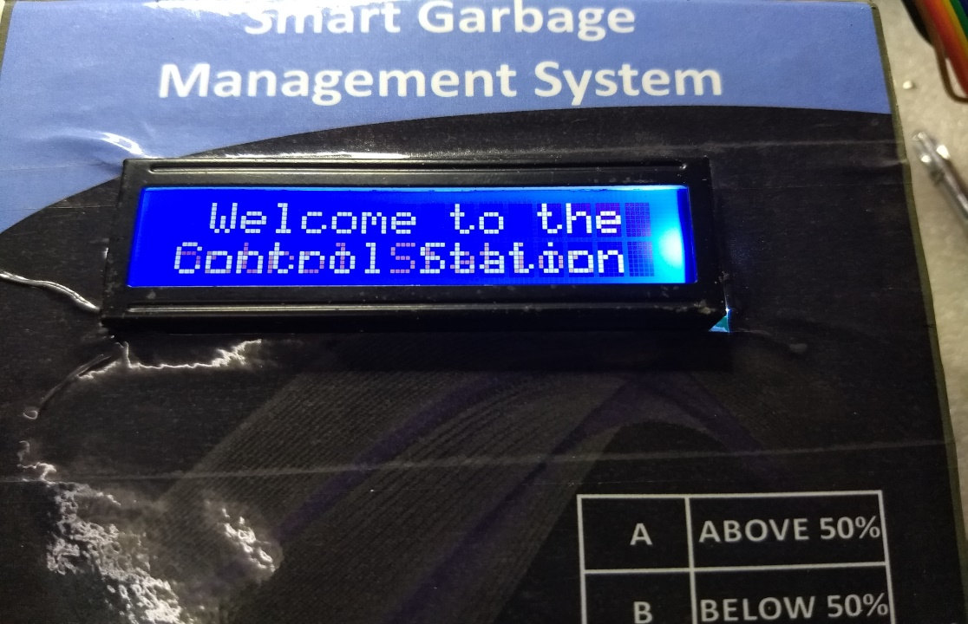

1. Now then the welcome message is on the LCD display then there will be the initial status i.e bins are empty will be displayed on the LCD display



1. And now if the bins are half filled of there will be following message will be displayed.

 

1. And now then if the bins are fully filled then there will be following message will be displayed on the screen.

 